Test Plan Template

Department: quality assurance
Version: v1
Generated On: 2026-02-26

Introduction

Riya's solution private limited operates within the SaaS industry, employing 100 professionals. This document addresses a high-risk level context, focusing on critical validation and assurance processes. The objective of this test plan is to verify that the application meets all functional and non-functional requirements as defined in the product specifications. Testing will validate feature correctness, system stability, performance benchmarks, security controls, and integration workflows. The plan aims to identify defects, ensure requirement traceability, confirm user acceptance criteria are met, and certify the system’s readiness for production deployment.

Purpose

The objective of this test plan is to verify that the application meets all functional and non-functional requirements as defined in the product specifications. Testing will validate feature correctness, system stability, performance benchmarks, security controls, and integration workflows.
This plan aims to identify defects early in the development cycle, ensure complete requirement traceability, and confirm that user acceptance criteria are fully met. It serves as a comprehensive guide to certify the system’s readiness for production deployment, minimizing risks associated with high-risk operations.
By systematically validating all aspects of the application, this test plan supports Riya's solution private limited in maintaining high-quality standards and delivering reliable SaaS solutions to its customers. It ensures that all critical functionalities operate as intended under expected conditions and that the system can handle anticipated workloads without failure.

Project Overview

Riya's Solution Private Limited is undertaking a high-risk project focused on ensuring the application meets all defined functional and non-functional requirements. This initiative is critical to validate feature correctness, system stability, performance benchmarks, security controls, and integration workflows. The project aims to identify defects early, maintain requirement traceability, and confirm that user acceptance criteria are fully satisfied.
The ultimate goal is to certify the system’s readiness for production deployment, minimizing operational risks and ensuring a seamless user experience. Given the high-risk nature of this project, thorough testing and validation processes are prioritized to mitigate potential issues before release. This project overview encapsulates the strategic intent to deliver a robust, secure, and reliable SaaS solution aligned with the company’s quality standards.

Scope

This test plan applies to the application developed by Riya's solution private limited, focusing on verifying that the software meets all functional and non-functional requirements specified in the product documentation. It encompasses validation of feature correctness, system stability, performance benchmarks, security controls, and integration workflows. The scope includes identifying defects, ensuring requirement traceability, confirming user acceptance criteria, and certifying the system's readiness for production deployment. Testing activities will cover all modules and components within the application to ensure comprehensive quality assurance aligned with the high-risk level of the project.

Testing Strategy

The testing strategy for Riya's solution private limited focuses on comprehensive validation of all functional and non-functional requirements as defined in the product specifications. This includes rigorous verification of feature correctness, system stability, performance benchmarks, security controls, and integration workflows. Testing activities will be structured to identify defects early, ensure traceability to requirements, and confirm that user acceptance criteria are fully met.
Multiple testing levels will be employed, including unit testing, integration testing, system testing, and user acceptance testing (UAT). Automated testing tools will be leveraged where feasible to increase efficiency and coverage, particularly for regression and performance testing. Security testing will incorporate vulnerability scanning and penetration testing to safeguard against potential threats.
The overall goal is to certify the system’s readiness for production deployment by ensuring all critical defects are resolved and performance standards are achieved. Continuous feedback loops between development and testing teams will facilitate rapid issue resolution and maintain alignment with project objectives.

Testing Objectives

The objective of this test plan is to verify that the application meets all functional and non-functional requirements as defined in the product specifications. Testing will validate feature correctness, system stability, performance benchmarks, security controls, and integration workflows.
This plan aims to identify defects early and ensure comprehensive requirement traceability throughout the testing lifecycle. It will confirm that user acceptance criteria are met, providing confidence that the product aligns with business needs and user expectations.
Additionally, the testing objectives include certifying the system’s readiness for production deployment by validating that all critical functionalities operate as intended under expected load conditions and that security measures effectively protect against vulnerabilities.

Test Assumptions

The test assumptions for this plan include that the application environment is stable and configured according to the product specifications. It is assumed that all required resources, including test data, tools, and access permissions, will be available throughout the testing period. The testing team assumes that the development team has completed all code merges and deployments prior to test execution. It is also assumed that any third-party integrations are functional and accessible for integration testing.
Testing assumes that the defined functional and non-functional requirements are complete and accurately documented, enabling effective validation of feature correctness, system stability, performance benchmarks, security controls, and integration workflows. User acceptance criteria are presumed to be clearly established and agreed upon by stakeholders to confirm readiness for production deployment.
It is assumed that defect tracking and communication channels will be maintained efficiently to facilitate timely resolution of issues. Additionally, the test environment will mirror production conditions closely enough to ensure valid results. Any deviations from these assumptions may impact the accuracy and completeness of the testing outcomes.

Test Data Approach

The test data approach for Riya's solution private limited focuses on creating and managing data sets that comprehensively cover functional and non-functional requirements. Test data will be designed to validate feature correctness, system stability, performance benchmarks, security controls, and integration workflows as outlined in the product specifications. Synthetic data generation techniques will be employed to simulate realistic user scenarios while ensuring compliance with data privacy standards. Masking and anonymization will be applied to any production-derived data to protect sensitive information. Test data sets will be version-controlled and maintained to ensure repeatability and traceability throughout the testing lifecycle.
Data subsets will be created to represent edge cases, boundary conditions, and typical usage patterns to identify defects effectively and confirm user acceptance criteria are met. Automated scripts will populate test environments with the required data before test execution, minimizing manual intervention and reducing errors. Continuous validation of test data integrity will be performed to maintain system readiness for production deployment. Collaboration between development, QA, and security teams will ensure that test data aligns with evolving requirements and risk assessments.
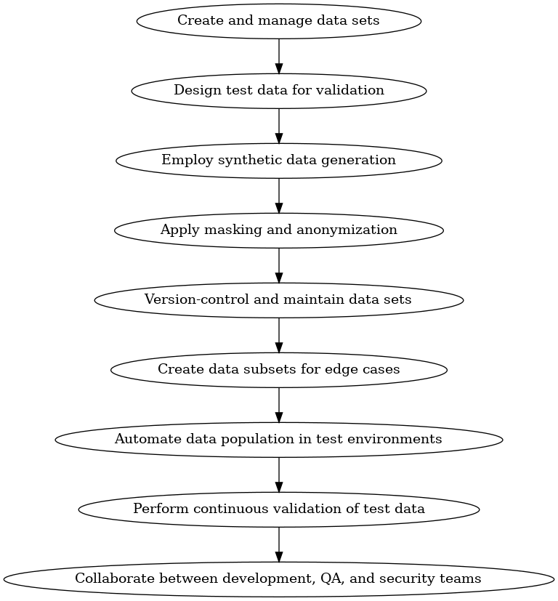

Levels of Testing

Testing at Riya's Solution Private Limited is structured across multiple levels to ensure comprehensive validation of the SaaS product. Unit Testing focuses on verifying individual components for correctness and stability, ensuring that each function performs as expected in isolation. Integration Testing evaluates the interactions between modules, confirming that workflows and data exchanges operate seamlessly across the system.
System Testing assesses the complete and integrated application against the specified functional and non-functional requirements, including performance benchmarks and security controls. This level validates the overall system behavior in an environment that closely simulates production. User Acceptance Testing (UAT) is conducted to confirm that the solution meets user acceptance criteria and business needs, certifying readiness for production deployment.
Each testing level is designed to identify defects early, ensure requirement traceability, and verify that the application meets all functional and non-functional requirements as defined in the product specifications. This layered approach supports the high-risk profile of our projects by systematically validating feature correctness, system stability, performance, security, and integration workflows.
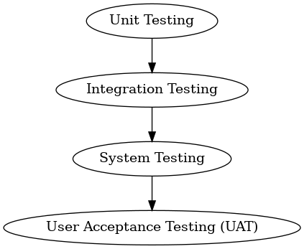

Execution Strategy

The execution strategy for Riya's Solution Private Limited focuses on a structured approach to validate that the application meets all functional and non-functional requirements as defined in the product specifications. This involves comprehensive testing phases designed to verify feature correctness, system stability, performance benchmarks, security controls, and integration workflows. The strategy prioritizes early defect identification and continuous requirement traceability to ensure alignment with user acceptance criteria.
Execution will be carried out in iterative cycles, allowing for incremental validation and timely feedback incorporation. Each cycle will include planning, test design, execution, defect logging, and review. Cross-functional collaboration between development, QA, and product teams will be emphasized to maintain transparency and accelerate issue resolution. Risk mitigation measures will be integrated throughout to address the high-risk level associated with this project.
The plan aims to certify the system’s readiness for production deployment by ensuring all critical defects are resolved and performance benchmarks are consistently met. Continuous monitoring and reporting mechanisms will be established to track progress against defined objectives. This execution strategy ensures that the final deliverable aligns with business goals and maintains high quality standards.

Environment Requirements

The environment requirements for this project are critical to ensure the application meets all functional and non-functional specifications as outlined in the product documentation. The testing environment must replicate the production environment as closely as possible to validate feature correctness, system stability, and performance benchmarks. This includes matching hardware configurations, network settings, and software versions to avoid discrepancies during deployment.
Security controls must be enforced within the test environment to simulate real-world conditions and identify potential vulnerabilities. Integration workflows require connectivity to dependent systems and services, which must be available and configured correctly. Additionally, the environment should support automated testing tools and monitoring solutions to track performance and detect defects efficiently.
The environment must provide sufficient resources to handle the expected load and concurrency levels to accurately measure system performance under stress. Data used in testing should be representative of production data while ensuring compliance with any applicable data privacy regulations. Proper environment isolation is necessary to prevent interference from other projects or external factors, maintaining test integrity and reliability.

Dependencies

This project relies on several critical dependencies to ensure successful delivery and operational stability. Coordination with internal teams and external vendors is essential to meet the defined objectives.
Dependency | Owner | Impact
Product Specification Documents | Product Management Team | Essential for validating feature correctness and requirement traceability.
Development Environment Setup | IT Infrastructure Team | Required to ensure system stability and performance benchmarks can be tested accurately.
Security Controls Framework | Security Team | Critical for validating security controls and compliance before production deployment.
Integration APIs | Third-Party Vendors | Necessary for testing integration workflows and ensuring seamless system interoperability.
User Acceptance Testing Group | Quality Assurance Team | Vital for confirming user acceptance criteria are met prior to release.
Timely availability and coordination of these dependencies directly affect the ability to identify defects and certify the system’s readiness for production deployment. Any delays or issues in these areas could impact the overall project timeline and risk level.

